Objectives of this assignment:
- to explore time complexity and “real time” of a well-known algorithm

Use This File
- USE EDITABLE THIS FILE AS THE STARTING DOCUMENT YOU WILL TURN IN. DO NOT DELETE ANYTHING FROM THIS FILE: JUST INSERT EACH ANSWER RIGHT AFTER ITS QUESTION/PROMPT.
- IF USING HAND WRITING (STRONGLY DISCOURAGED), USE THIS FILE BY CREATING SUFFICIENT SPACE AND WRITE IN YOUR ANSWERS.
- FAILING TO FOLLOW TURN IN DIRECTIONS /GUIDELINES WILL COST A 30% PENALTY.

What you need to do: (Use this file to INSERT your answers as indicated below)
- Implement the QuickSort algorithm to sort an array. (See Lecture or Textbook for the QuickSort algorithm)
- Collect the execution time T(n) as a function of n
- Plot the functions $\frac{T(n)}{g_{1}(n)}$, $\frac{T\left(n\right)}{g_{2}(n)},$ and $\frac{T(n)}{g_{3}(n)}$ as a function of n on three separate graphs. We assume that:
  - $g_{1}\left(n\right)=$ 0.001$n^{3}$
  - $g_{2}\left(n\right)={10nlog\left(n\right) }^{}$
  - $g_{3}\left(n\right)= 0.01n^{2}$
- In Module 5, we establish that the average running time T(n) of QuickSort is Θ(n.log(n)). Discuss T(n) in light of the graphs you plotted above. Use the prediction techniques learned in M1: Programming Assignment (See Early questions trying to infer the shape of the plots)

Objective: The objective of this programming assignment is to implement in your preferred language the QuickSort algorithm to sort a list of numbers. We are interested in exploring the relationship between the time complexity and the “real time”. For this exploration, you will collect the execution time T(n) as a function of n and plot the $\frac{T(n)}{g_{1}(n)}$, $\frac{T\left(n\right)}{g_{2}(n)},$ and $\frac{T(n)}{g_{3}(n)}$on the same graph (If you cannot see clearly the shape of the plots, feel free to separate plots.). Try to predict ahead the shapes of $\frac{T(n)}{g_{1}(n)}$, $\frac{T\left(n\right)}{g_{2}(n)},$ and $\frac{T(n)}{g_{3}(n)}$to check whether your plots are correct. Finally, discuss your results.

Program to implement
collectData()
Generate an array G of HUGE length L (as huge as your language allows) with random values capped at some max value (as supported by your chosen language). Try to reach at least the value L for 250,000.
for n = 10,000 to L (with step 5,000)
copy in Array A n first values from Array G // (declare Array A only ONCE out of the loop)

Take current time Start // We time the sorting of Array A of length n
// (Use nanoseconds resolution if possible)
QuickSort(A,0,n-1)
Take current time End // T(n) = End - Start (Use nanoseconds)
Store the value n and the values $\frac{T(n)}{g_{1}(n)}$, $\frac{T\left(n\right)}{g_{2}(n)},$ and $\frac{T(n)}{g_{3}(n)}$in a file F where T(n) is the execution time

Advice:
The pseudocode assumes arrays that start with index 1. So, an array A with n elements is an array A[1], A[2]..., A[n-1], A[n]. With most programming languages, an array A with n elements is an array A[0], A[2]..., A[n-1], A[n-1]. When implementing pseudocode that uses some array A with $n$ elements, I advise you to declare an array with $n+1$ elements and just ignore (not use) A[0]. This way, you can directly implement the algorithm without worrying about indices changes.

Data Analysis
Use any plotting software (e.g., Excel) to plot the values $\frac{T(n)}{g_{1}(n)}$, $\frac{T\left(n\right)}{g_{2}(n)},$ and $\frac{T(n)}{g_{3}(n)}$in File F as a function of n. File F is the file produced by the program you implemented. Discuss your results based on the plots. (Hint: is T(n) closer to K.$g_{1}(n)$, $K.g_{2}\left(n\right),$or K.$g_{3}(n)$ where K is a constant? See M1: Programming Assignment).

Answer where indicated below. Recall that answers must be well written, documented, justified, and presented to get full credit.

- (25 points) Implement the QuickSort algorithm to sort an array. (See the appendix of this assignment for the QuickSort algorithm)
.... answer here
Actions to complete:
1) ssh into a Tux machine
2) clear the screen on the Tux machine (use the command clear)
3) Display the current date (use the command date)
4) Compile your program
5) Execute your program showing that your algorithm sorts correctly an array with 12 elements. We must see the original array and the sorted array.
6) Take a screenshot of the Tux terminal and insert here (below). Your screenshot should look like this template screenshot (we should see the username, the date, the commands typed, and the results): a 50 points penalty will be applied if there is no screenshot or if the screenshot does not include ALL the required information. Screenshot should be as readable as the screenshot below. If this task is not completed on a Tux machine, no credit will be awarded.
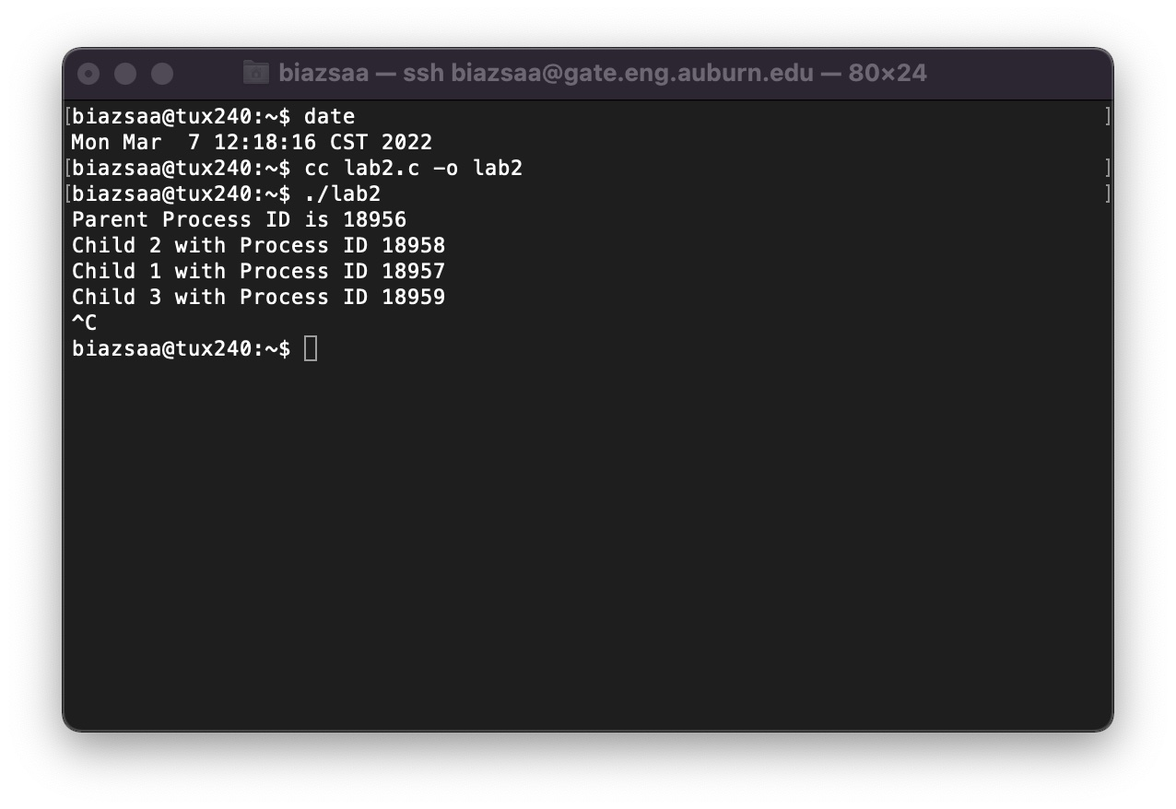

.... (10 points for the screenshot if your program works and produces correct data) Insert here YOUR screenshot with Tux terminal. Without screenshot with all required information 50 points will be taken off.
...(15 points if screenshot PLUS program works and produces correct data)

Provide here the instructions/directions to compile and execute your code.

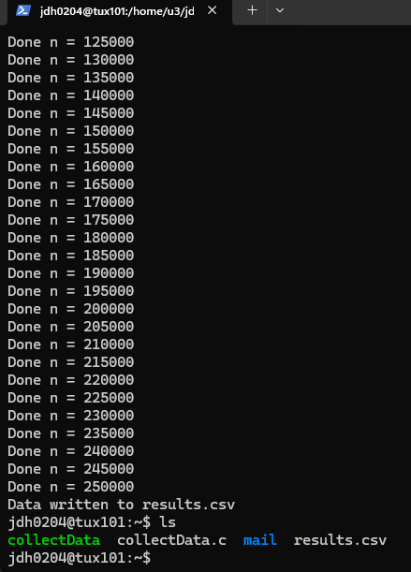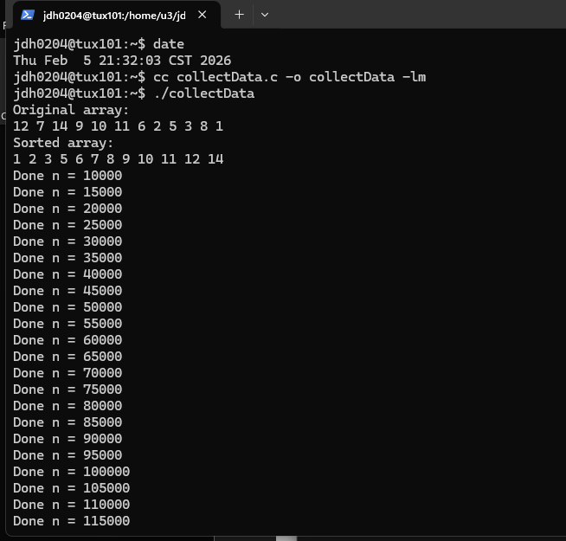

2. (10 points) Collect the execution time T(n) as a function of n. Record the values n, T(n), $\frac{T(n)}{g_{1}(n)}$, $\frac{T\left(n\right)}{g_{2}(n)},$ and $\frac{T(n)}{g_{3}(n)}$in a csv (comma-separated-values) file.
Turn in this csv file with your submission
3. (3x15 points) Plot the functions $\frac{T(n)}{g_{1}(n)}$, $\frac{T\left(n\right)}{g_{2}(n)},$ and $\frac{T(n)}{g_{3}(n)}$ as a function of n on three separate graphs (15 points per graph).
Insert here the three graphs/plots (do not insert here data file tables from F. Only plots are expected)

4. (20 points) In Module 4, we will establish that the running time T(n) of QuickSort is Θ(n.log(n)).
Discuss here T(n) in light of the graphs you plotted above. Use the prediction techniques learned in M1: Programming Assignment (See Early questions trying to infer the shape of T(n) and determine the asymptotic growth). Discuss whether your plots confirm what we will learn in Module M4, i.e., that the running time T(n) of QuickSort is Θ(n.log(n)). Use the techniques presented/advised in the previous programming assignment. These techniques allow you to predict the shape of the plots. Therefore, predict the shape, then check whether your data/plot support your prediction.

- Before plotting the data, the expected behavior of QuickSort’s average running time is O(n log n). Therefore, we expect the ratio T(n)/g₂(n), where g₂(n) = 10n log(n), to approach a constant, while T(n)/g₁(n) and T(n)/g₃(n) should not remain constant.
- From the plotted graphs, T(n)/g₂(n) remains relatively stable as n increases, indicating that T(n) grows proportionally to n log n. In contrast, T(n)/g₁(n) decreases toward zero, showing that n³ grows much faster than the actual running time, and T(n)/g₃(n) also does not remain constant, indicating that n² does not match the growth rate either.
- These results confirm the theoretical analysis that the average running time of QuickSort is O (n log n). The experimental data supports this conclusion because the ratio involving n log n best approximates a constant factor, which is consistent with the definition of O-notation.

What you need to turn in (3 separate items):
- Electronic copy of your source program of collectData program
- Electronic copy of the csv file F recording the values n, T(n), $\frac{T(n)}{g_{1}(n)}$, $\frac{T\left(n\right)}{g_{2}(n)},$ and $\frac{T(n)}{g_{3}(n)}$
- Electronic copy of this file (including your answers) (standalone). Submit the file as a Microsoft Word or PDF file.
Do your screenshots include all required information (we should see the username, the date, the commands typed, and the result)

Grading
- See points distribution assigned to each task/question
Appendix: QuickSort Algorithm.
At this stage, you do NOT need to fully understand QuickSort (It will be presented and explained in Module 5)). Implement QuickSort exactly the way it is described below. Read about it.

Any missed element will get at least a 25 point penalty.

Appendix (Algorithm To Implement)

